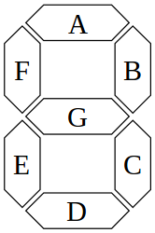
What segments need to be on to represent each number? Fill out the table below. The first row is done for you as an example.

Decimal Number | A | B | C | D | E | F | G
0 | 1 | 1 | 1 | 1 | 1 | 1 | 0
1
2
3
4
5
6
7
8
9

