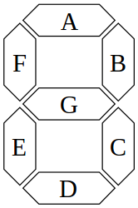
What is the decimal (base 10) equivalent to the number represented by each byte? Fill out the table, the first one is done for you.

Decimal Number | A | B | C | D | E | F | G | DP | Decimal
0 | 0 | 0 | 0 | 0 | 0 | 0 | 1 | 1 | 3
1 | 1 | 0 | 0 | 1 | 1 | 1 | 1 | 1
2 | 0 | 0 | 1 | 0 | 0 | 1 | 0 | 1
3 | 0 | 0 | 0 | 0 | 1 | 1 | 0 | 1
4 | 1 | 0 | 0 | 1 | 1 | 0 | 1 | 1
5 | 0 | 1 | 0 | 0 | 1 | 0 | 0 | 1
6 | 0 | 1 | 0 | 0 | 0 | 0 | 0 | 1
7 | 0 | 0 | 0 | 1 | 1 | 1 | 1 | 1
8 | 0 | 0 | 0 | 0 | 0 | 0 | 0 | 1
9 | 0 | 0 | 0 | 1 | 1 | 0 | 0 | 1

